**Bank Customer Churn Prediction**

**Analysis the parameters.**

1. **Gender**

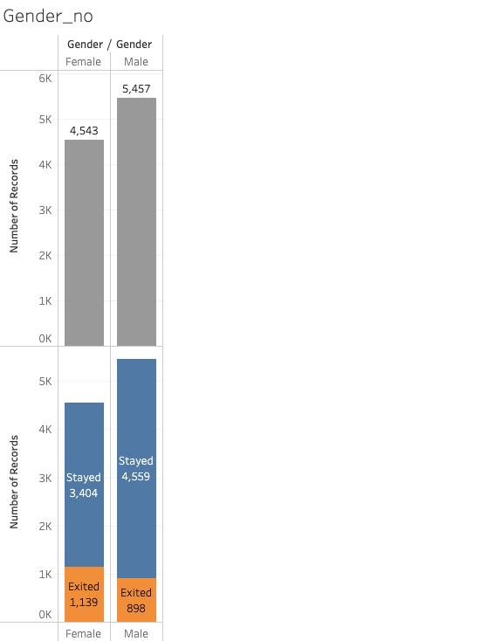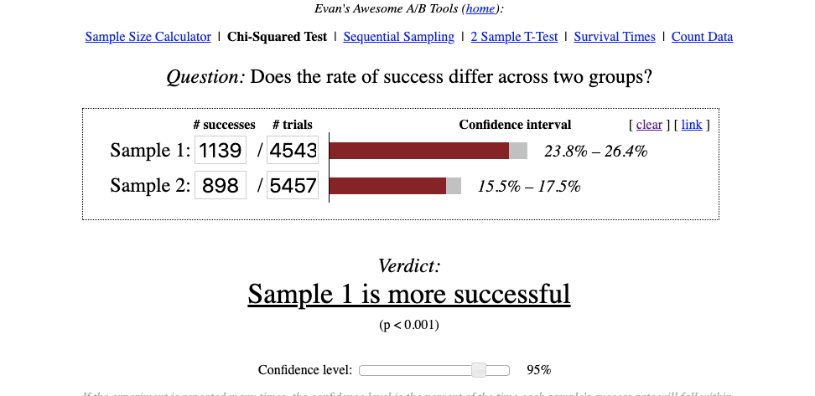

* From the above plot we can clearly see that the number of the female left the bank is obviously more than the males.
* Also, we can see from the chi square test that the Sample 1 which is female are more successful compare to males.
* And the value of p<0.001

1. **Has Credit Card**

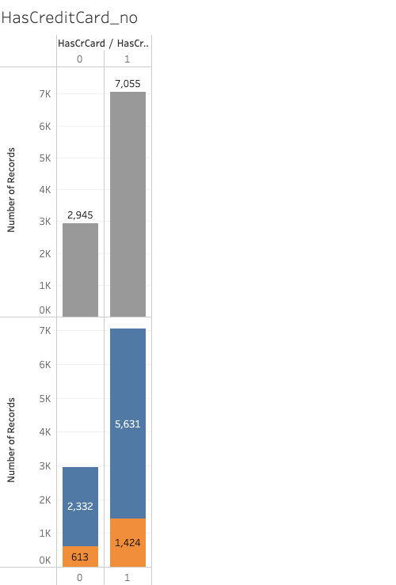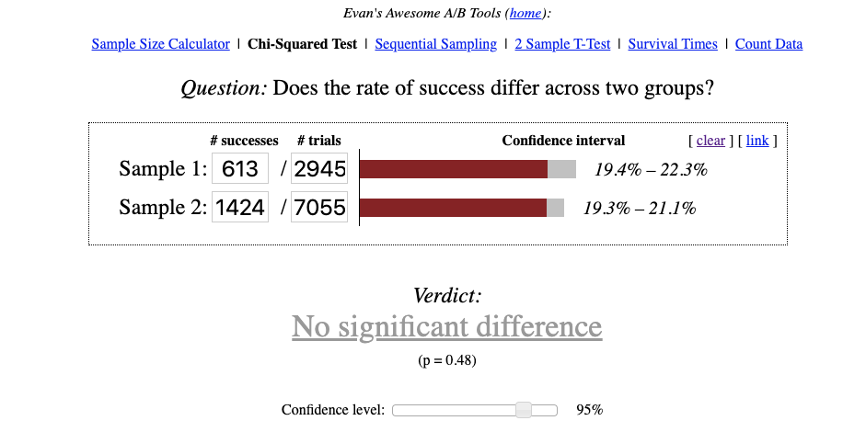

* From the above bar plot we can see that the people exiting the bank is more in case of people having the credit card.
* But after calculating the chi square test it is clear from the result that both person having the credit and not having the credit card has no significance.
* So, having a credit card does not help us to land into conclusion that people will exit the bank even though people exiting the bank is more.

1. **Is Active**

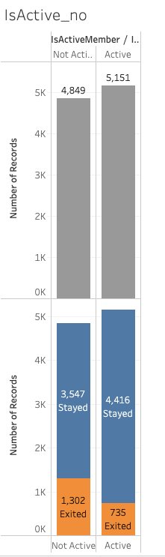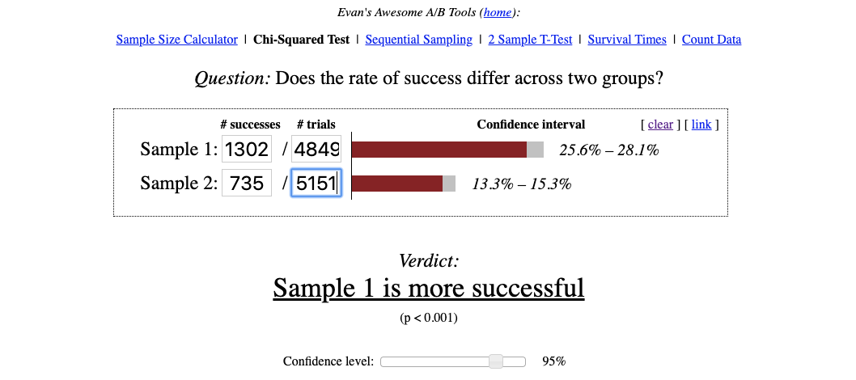

* From the above bar plot we can see that more number of people left the bank who were not active users.
* Also after calculating the chi square test we can say that the not active users are most likely to leave the bank. And the value of p<0.001

1. **Number Of products**

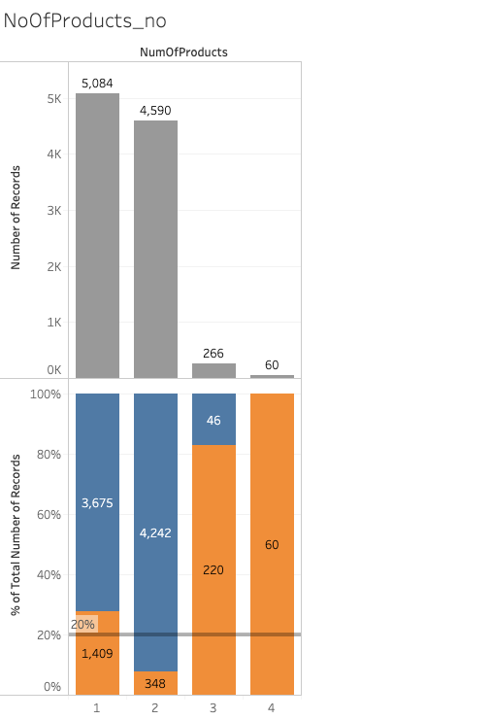 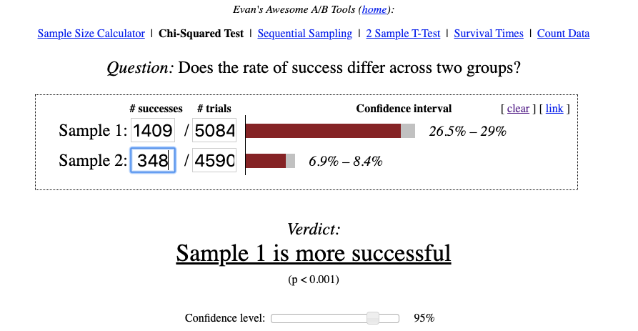

* In the above bar plot we can see that that number of people exiting the bank is more with people with people having only one product and less in case of the people having two products.
* So if we push the customer to buy one more product so the chance of people leaving the bank will decrease.
* And the value of p<0.001.

1. **Location**

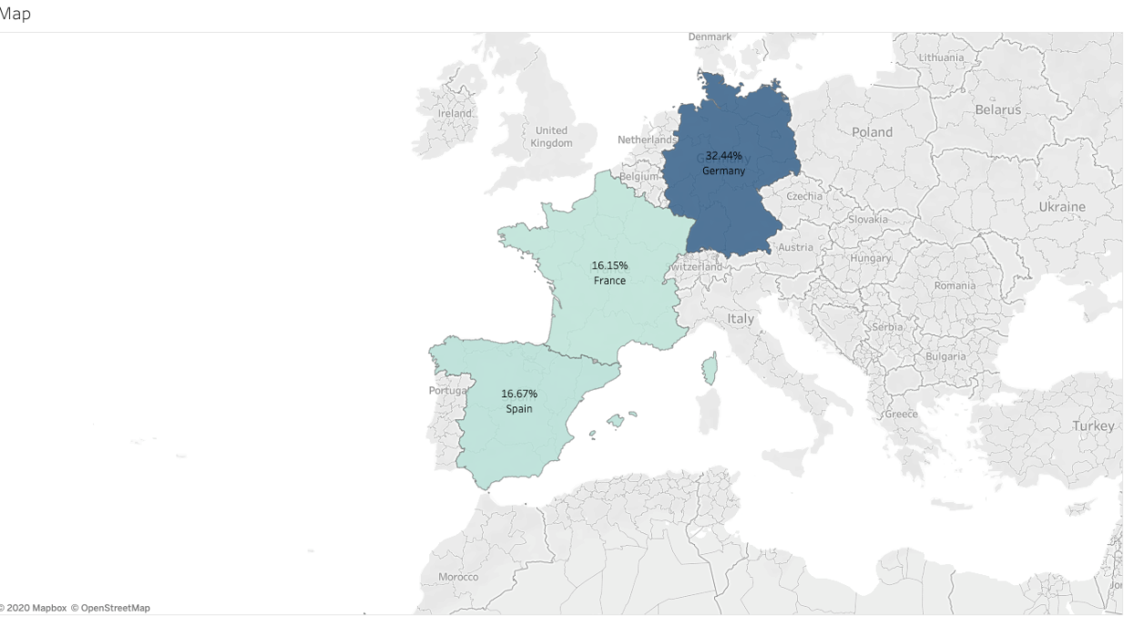

* As from the above figure we can see that people exiting the bank is more in Germany as compared to Spain and France.

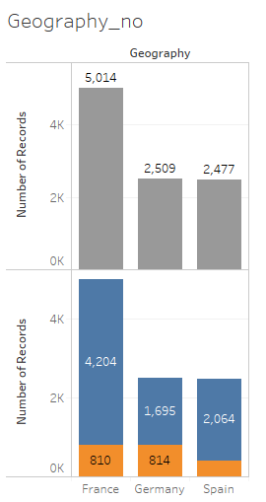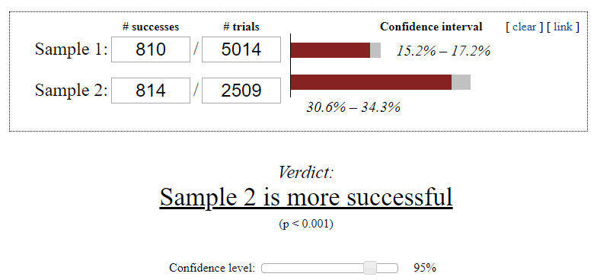

* After analysis of the plot and chi square test we can say that is some issue faced by the Germany customer.

1. **Age**

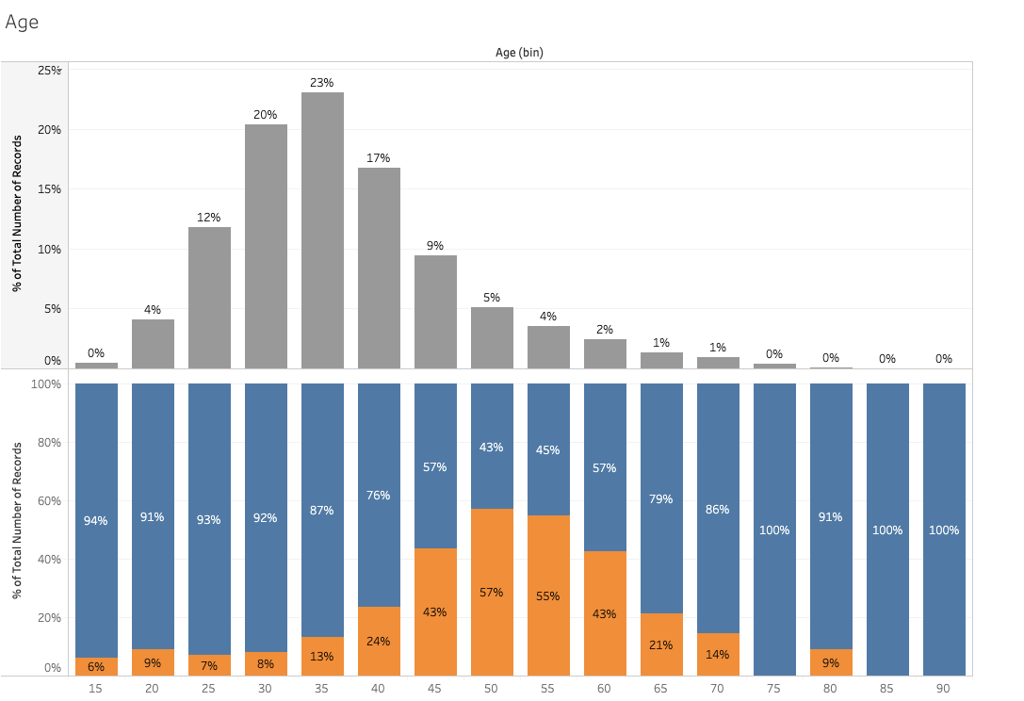

* From the above plot we can see that data is normally distributed. So we can’t say much from this plot.
* But we can say that very few people between the 25-40 years of customer left.

1. **Credit Score**

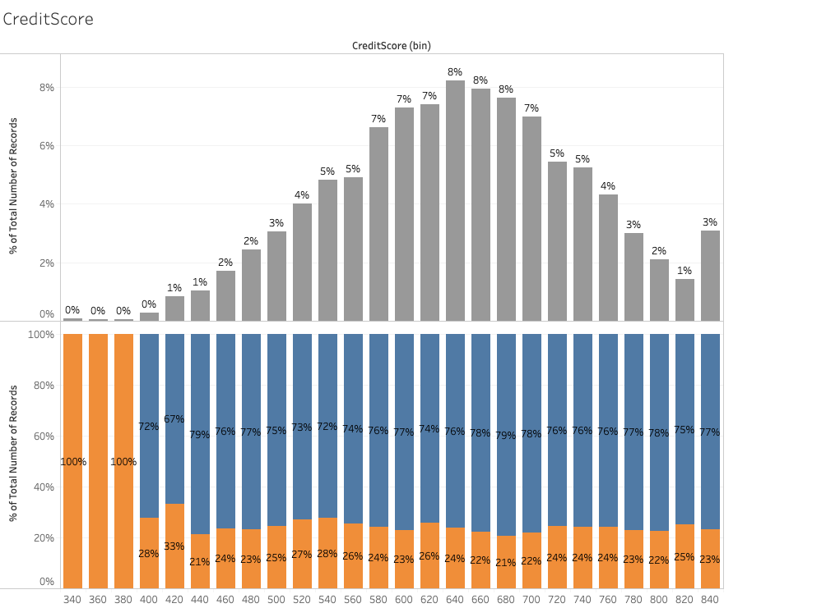

* From the above plot we can see that data is normally distributed. So we can’t say much from this plot.

1. **Tenure**

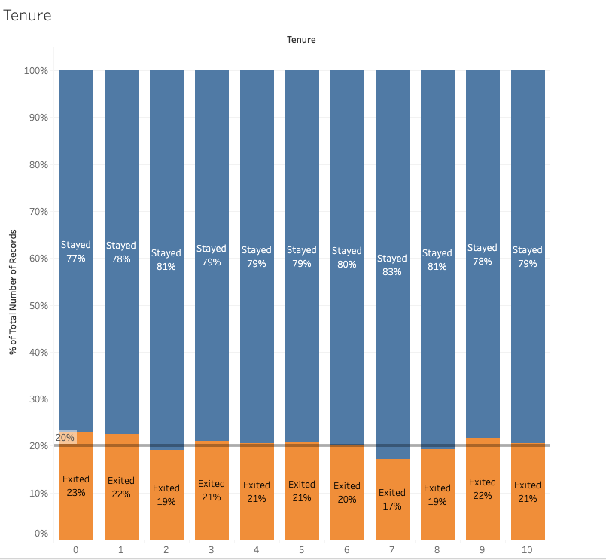

* Tenure has no impact on whether the person will leave the bank or not.

1. **Balance**

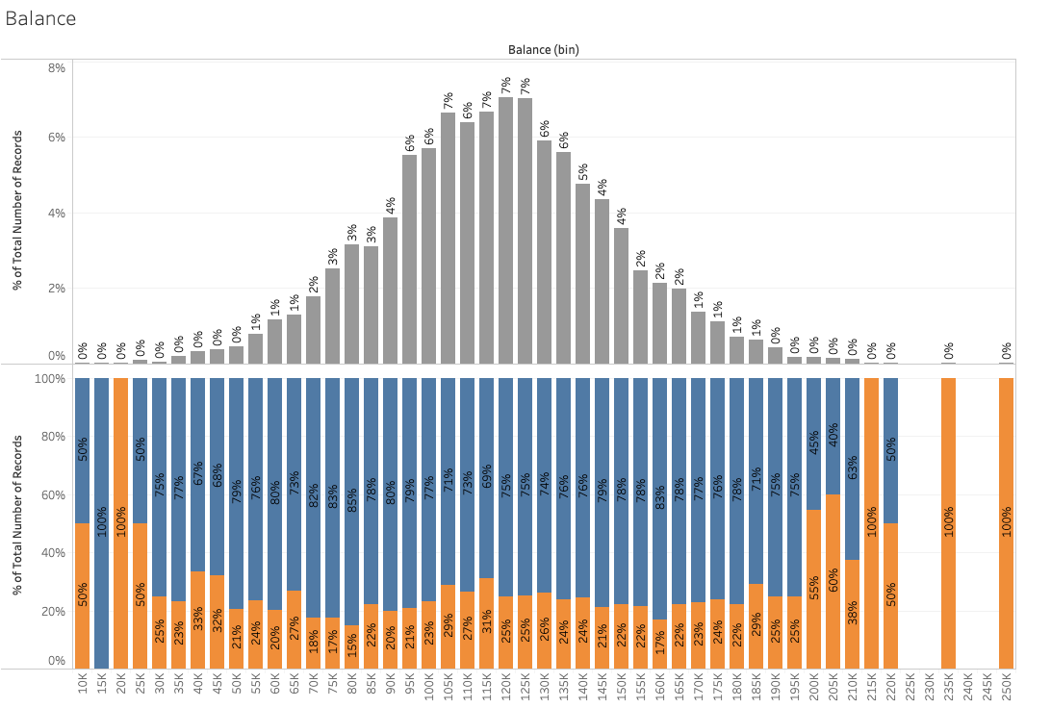

* Balance is also not having a major impact on whether the person will leave the bank or not.